Start by connecting one leg of the button to the positive rail on the bread board. Next, add the 10K resistor between the other leg and ground. Then, add a led between pin 13 on the Arduino and ground.   After that, connect the negative rail on the bread board to the ground on the Arduino and the positive rail to 5V.  Finally, connect the leg of the push button with the 10K resistor to pin two on the Arduino.

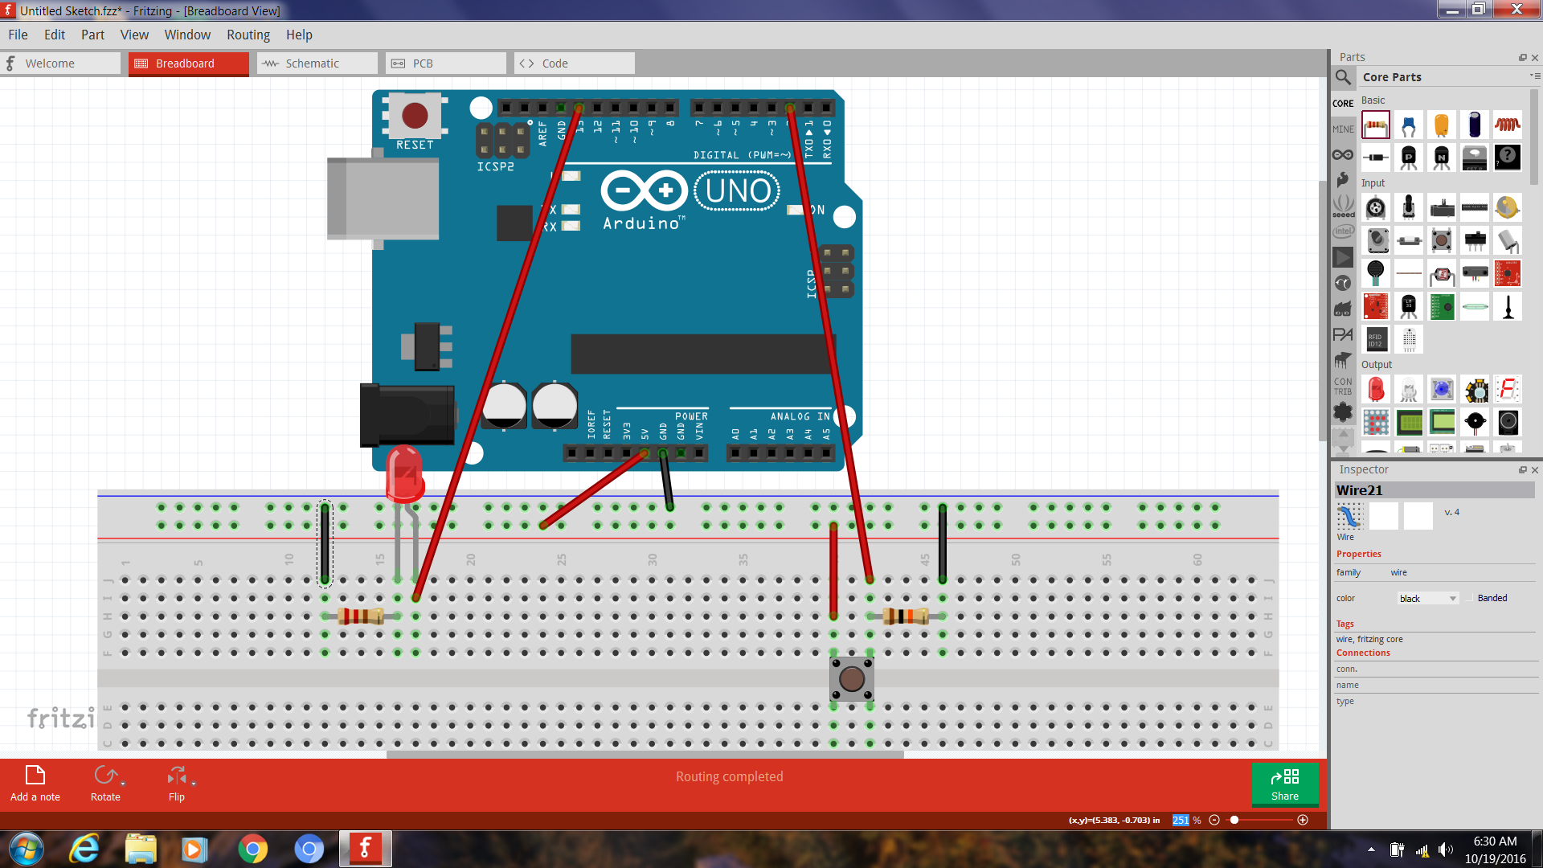

**The program**

int switchPin = 2;

int ledPin = 13 ;

boolean lastButton = LOW;

boolean currentButton = LOW;

boolean started = false;

boolean timer = false;

long startTime;

long endTime;

long randomTime;

float elapsedTime;

void setup()

{

pinMode(switchPin, INPUT);

pinMode(ledPin, OUTPUT);

Serial.begin(9600);

}

boolean debounce(boolean last)

{

boolean current = digitalRead(switchPin);

if(last != current)

{

delay(5);

current = digitalRead(switchPin);

}

return current;

}

void loop()

{

currentButton = debounce(lastButton);

if(lastButton == LOW && currentButton == HIGH)

{

started = !started;

lastButton = HIGH;

}

lastButton = currentButton;

if(started == true && timer == false)

{

Random();

timer = true;

}

if(started == false && timer == true)

{

Stop();

timer = false;

}

}

void Random()

{

randomTime = random(4,10);

randomTime = randomTime*1000;

digitalWrite(ledPin, HIGH);

delay(100);

digitalWrite(ledPin, LOW);

delay(randomTime);

Start();

}

void Start()

{

startTime = millis();

digitalWrite(ledPin, HIGH);

}

void Stop()

{

endTime = millis();

elapsedTime = (endTime - startTime)+5;

elapsedTime = elapsedTime/1000;

Serial.print("Time Seconds: ");

Serial.println(elapsedTime);

digitalWrite(ledPin, LOW);

}

**Running the test**

1. Upload your program to the Arduino
2. Open the Serial Monitor at 9600 baud
3. Push the pushbutton and the LED will flash momentarily.
4. The LED will come on at some random time from 4 to 10 seconds.
5. When the light comes on, push the button and the serial monitor will display your reaction time.